Anchor Resources for Instruction in GSSD
EARLY LEARNING 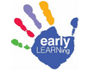
Play and Exploration: Early Learning Program Guide  (PreK & K)  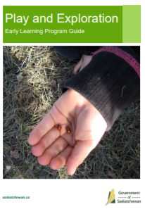  The aim of this Ministry of Education guide is to promote high quality, age-appropriate, play-based learning experiences for three-, four- and five-year-old children in a variety of settings. It is available online at this link. | Essential Learning Experiences (PreK)  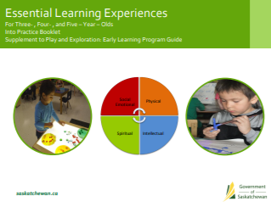  This Ministry of Education resource focuses on those learning experiences that are essential for young children’s learning and development in four domains: social emotional, physical, intellectual and spiritual. It is available online at this link. | Responsive Teaching, Practice and Assessment in Early Learning Programs (PreK & K)  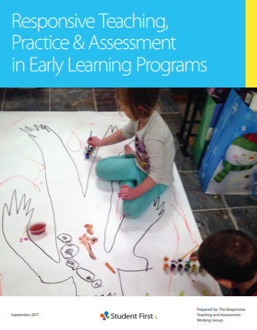  Developed by the Responsive Teaching and Assessment Working Group for the ESSP early years outcome, this document provides guidelines and direction for early learning programs. It is available online at this link.
Literacy Beginnings  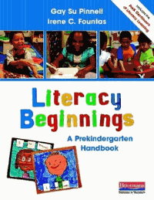  This key resource explains how to combine literacy instruction with activities that appeal to a child's natural curiosity and desire to play. | Expanding Expressions  This two-part kit (braided rope with beads and coloured discs) uses a multisensory approach to facilitate language awareness | Sounds Abound  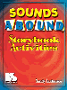  This resource includes phonological awareness activities for 43 children's books to help reinforce skills in word awareness, syllable awareness, rhyming, and sound awareness.

ENGLISH LANGUAGE ARTS

Fountas & Pinnell Literacy Continuum  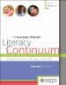  The continuum is used to set goals for students across eight instructional contexts. | Saskatchewan Reads  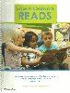  Access the document at the SaskReads website along with supporting resources. | Writing  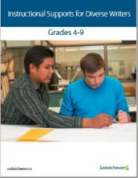  Two Ministry documents provide essential guidelines for writing instruction.  Instructional Supports for Diverse Writers 4-9  Provincial Writing Continuum
Word Study  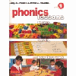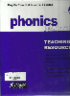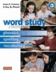  The Pinnell & Fountas Word Study series is the recommended resource for word work in grades 1 to 3. | Grade 6 – 12 Dialogic Learning and Book Clubs  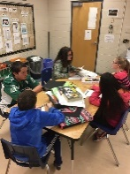  Suggested texts organized by context/theme suitable for study in a book club format have been recommended by GSSD teachers and are posted to the internal portal. Three units of study for grades 7, 8, and 9 designed with the dialogic learning stance are available. Resources may be borrowed from the GSSD Centralized Library. | Writing Strategies  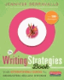  Jennifer Serravallo’s book is the “everything guide to developing skilled writers.” Teachers can find lessons to match to writing goals from the 300+ strategies provided in the book.
Literacy Quick Guide  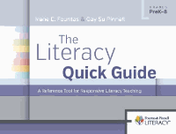  This book could aptly be called the abridged version of the Literacy Continuum. Instructional strategies for reading, writing, talking, and word study are described in conjunction with research-based practices. | Guided Reading  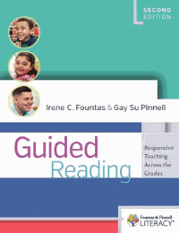  Fountas & Pinnell discuss the essential elements of guided reading in this resource. | Prompting Guides  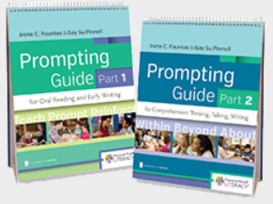  Fountas & Pinnell flip chart prompting guides for guided reading lessons are available for oral reading, comprehension, and fiction and non-fiction genres.

MATHEMATICS
Mathology  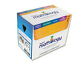  Grades 1 - 3 classrooms have access to Pearson’s Mathology resource --Box 1 and Box 2 for each grade plus a digital license to Mathology.ca. These activity-based kits are designed to promote understanding of big ideas in math. | Mathematics Learning Progression  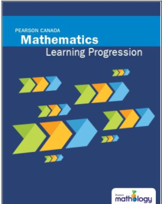  This research based Mathology resource demonstrates how students’ mathematical learning and knowledge grows over time. Two editions are available: K-3 and 4-9. | Knowledgehook  Grades 4 – 9 classrooms have premium accounts for Knowledeghook, an online resource focused on using formative assessments to identify and close gaps in students’ mathematical learning.
Cognition-based Assessment & Teaching - Michael T. Battista  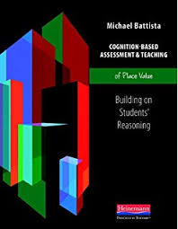  Battista’s four books are particularly helpful when planning for math intervention. Titles include:  - addition and subtraction  - fractions  - multiplication and division  - place value | SaskMath  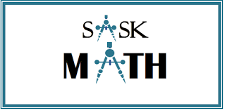  The SaskMath web and print resource has been developed to support high quality math instruction and assessment that includes Indigenous Ways of Knowing. | Math Makes Math Focus  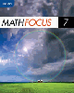  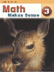  Sense  Pearson’s Math Makes Sense and Nelson’s Math Focus are approved textbooks for Grades 3-8.

